Monday 13th April 2020 Wooden Spoon Craft for All the Family
Hi everyone,
I thought this activity would be fun for all the family to do. Once you have decorated your spoon you can use your spoon to tell stories and sing songs to your little ones or if you have a baby sister or baby brother, I’m sure they would love it if you sang their favourite songs while holding and showing them your amazing decorated spoon.
There are 2 examples for you to choose from or you can do both. I hope you guys have great fun doing the activity and they look fab when finished - enjoy!
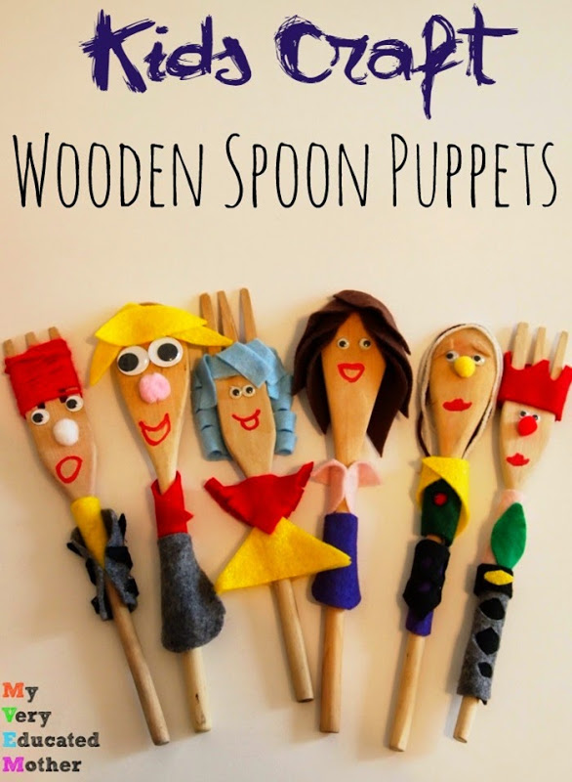
Example (1) instructions:
What you need:
- Wooden spoon
What you can use:
- Scrap felt, material, old clothing, odd socks
- Glue stick, double-sided tape or PVA glue
- Felt pens, sharpies or markers
- Scissors for adults to use
- Wool
- Ribbon
- String

Use arts and craft stuff you already have at home use anything you think will do the job.
Once you’ve got them, you’re ready to go! Having everything everywhere seems as if it’d be overwhelming, but magically things happen when you let kids simply touch and manipulate the materials with their hands, watch how creative they are.
- You can use wool or string for hair
- Dress your spoon with scrap material
- You can draw on the face
Have fun!

Alternative Example (made without glue)
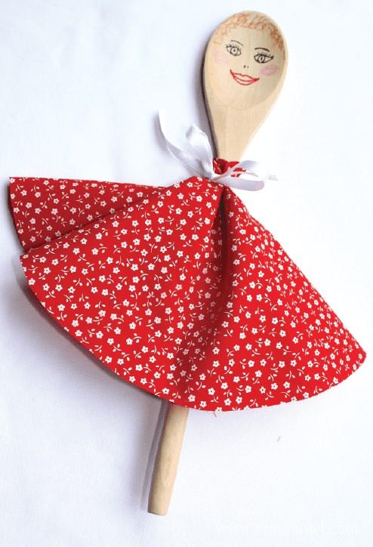

What you need:
1. A wooden spoon, some fabric, old clothes, T-towel (as big as a dinner plate), a dinner plate, markers, scissors for adults to use and a piece of ribbon or string or anything you think you can use to tie your fabric onto the spoon.
2. Draw around the dinner plate and cut out your circle. (or you can make a square)
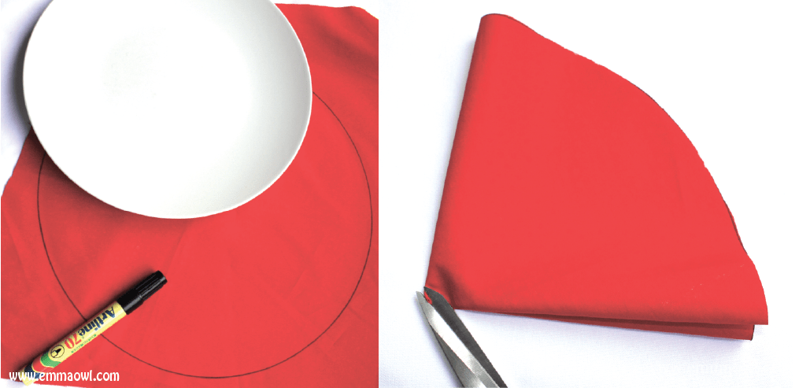

3. Fold the circle in half and half again and then cut the hole for the centre by just slightly snipping the corner.
4. slip the fabric over the handle of the spoon and tightly tie with a piece of ribbon or string or anything you have at home that would do the trick.
5. Draw the face, add hair if you like, using wool, string, fabric or tinfoil maybe make a wee tinfoil hat whatever you like it’s your creative art.
Why don’t you post and let us see your wooden spoon art on your online group or step by steps Facebook page
I hope you have fun.

Learning Opportunities:
- Sensory texture exploration
- Creativity and Imaginative Play
- Fine Motor Skills
- Concentration
- Language development
- Boost Self Esteem
- Problem solving – overcoming challenges
- Colour and shape recognition
- role-play social/emotional development

Story time: Why is it important to read to your little ones
Reading aloud and sharing stories can: help your child get to know sounds, words and language, and it helps them develop listening skills. ... spark your child's imagination and stimulate curiosity.
Start with the Listen song:
followed by Twinkle Twinkle Star- as these songs help settle the children before the story
Click on the link below. It’s a great interactive story.

https://www.youtube.com/watch?v=kBi_RoXKVo0

Once story ends, I thought it be nice to join in the penguin song
https://www.youtube.com/watch?v=c3c3UTYNZ6Q
And this last little song is from me x
https://www.youtube.com/watch?v=DHbO3cZhFbA

Feel free to leave comments on online group or step by steps Facebook page on how you got on with activity and story.
Love Annie Walker

